COVID-19 Memory Project: High School

Instructions: Type your responses to each question directly into this document. You may write as much as you wish, there is no page limit. If you would like to include any artwork or photos, you may insert them into this document.

Student’s Age

Date:

SCHOOL

How did you feel when you learned that schools would close because of the COVID-19 pandemic?

What do you like the most about online school?

What do you dislike the most about online school?

What do you miss the most about school?

How are you connecting with your school friends during the pandemic?

EXTRACURRICULAR ACTIVITIES

What activities did you do before the pandemic? (Sports, music, dance, etc. Please be specific.)

Are you continuing to do them now? If so, how? Do you use a virtual platform? Do you do them as you did before?

What do you miss most about doing these activities in person?

What do you like most about doing activities online?

FAMILY AND HOME

What questions do you have about the pandemic?

What has changed the most in your home because of the pandemic?

How do you spend your free time at home?

How have you stayed connected to extended family? How has this changed your relationships?

Are you learning new skills because of the pandemic? (Cooking, babysitting, house chores, arts, crafts, etc.?) If so, what are they?

SOCIETY

How has the pandemic affected your community? How has it affected our state?

How do you think the pandemic might impact your life in the future?

What strengths and weaknesses in our society are being exposed by the pandemic?

In which ways has the pandemic affected the economy?

What do you want future generations to know about what it’s like to experience a pandemic?

You may include artwork or photographs about how the pandemic has shaped your life here. Insert jpg photos or scans directly into this document.

If you submit your memory project and any other materials to the Utah Division of State History, it will become part of a permanent historical collection retained by the Utah Division of State History that will help future generations learn about this moment in history. It may be used by researchers, for museum and online exhibits, and for social media posts. Please complete and sign the release and donation form below with a parent, then follow the instructions to submit it by email. Your parent or guardian’s signature below gives express permission for the Utah Division of State History to use this Covid-19 Memory Project worksheet with your answers, other materials, and anything else you submit with the worksheet as described above.

Utah Division of State History
Covid-19 Memory Project Donation Agreement
This donation agreement is for cataloging purposes. The student’s name and personal information will not be disclosed to the public.

Student Name:
Parent/Guardian:
Address:
Phone:
Email:

Your Donation is the Utah Division of State History’s Covid-19 Memory Project worksheet with your answers and any other documents, artwork, photographs, or information you choose to submit.

****PLEASE READ AND E-SIGN AT THE BOTTOM****

Utah Division of State History’s Covid-19 Memory Project materials are donated as UNRESTRICTED GIFTS and are subject to the following:

- Utah Division of State History shall have the sole discretion to use Covid-19 Memory Project worksheets and materials donated as a part of its historic collections, exhibitions, social media platforms, reference for patrons, and for research and study. The Utah Division of State History has the right to quote, comment, and publish all or parts of the donations.
- Utah Division of State History shall have the sole discretion as to the use and retention of all Covid-19 Memory Project worksheets and materials donated, and for how long donated items shall be exhibited to the public.
- Utah Division of State History may digitize, photocopy or otherwise reproduce Covid-19 Memory Project worksheets and materials for the use of patrons.
- All donations of the Covid-19 Memory Project worksheets and materials are temporary until reviewed by staff.
*I have read the above stipulations and agree to the terms of the donation of the Covid-19 Memory Project worksheet and materials as outlined in this Donation Agreement.

*Donor: *Donor E-Signature: Date:

*Parent/Guardian: *Parent/Guardian E-Signature: Date:

Representative Utah Division of State History: Date:

Please email your completed documents as a PDF to lmbarr@utah.gov and contact Lisa Barr (801)755-8554 with questions.

Save your completed form in Google Docs or Word and convert to a PDF

How to Email the PDF in Word:
Go to “File” and “Save As”
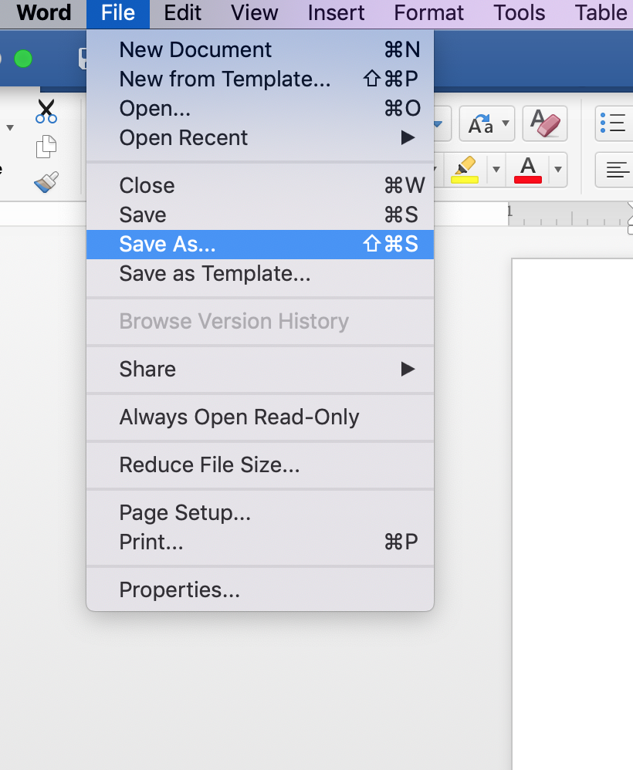

Then change from Word Doc to PDF and save to your computer
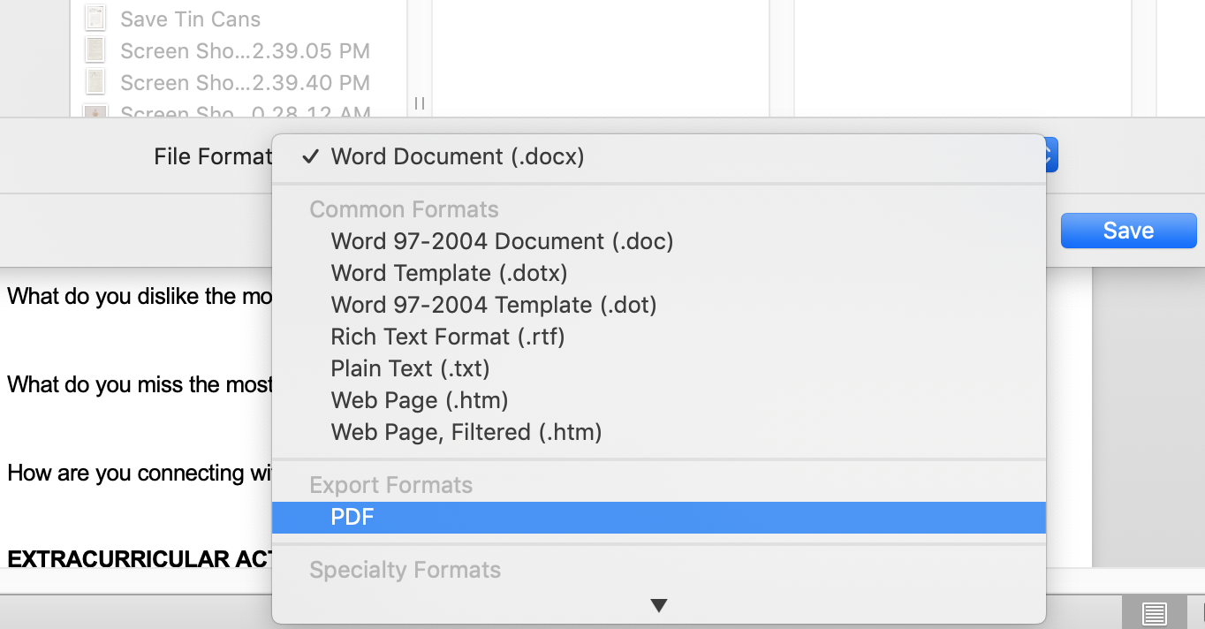

Then attach the PDF in your email lmbarr@utah.gov
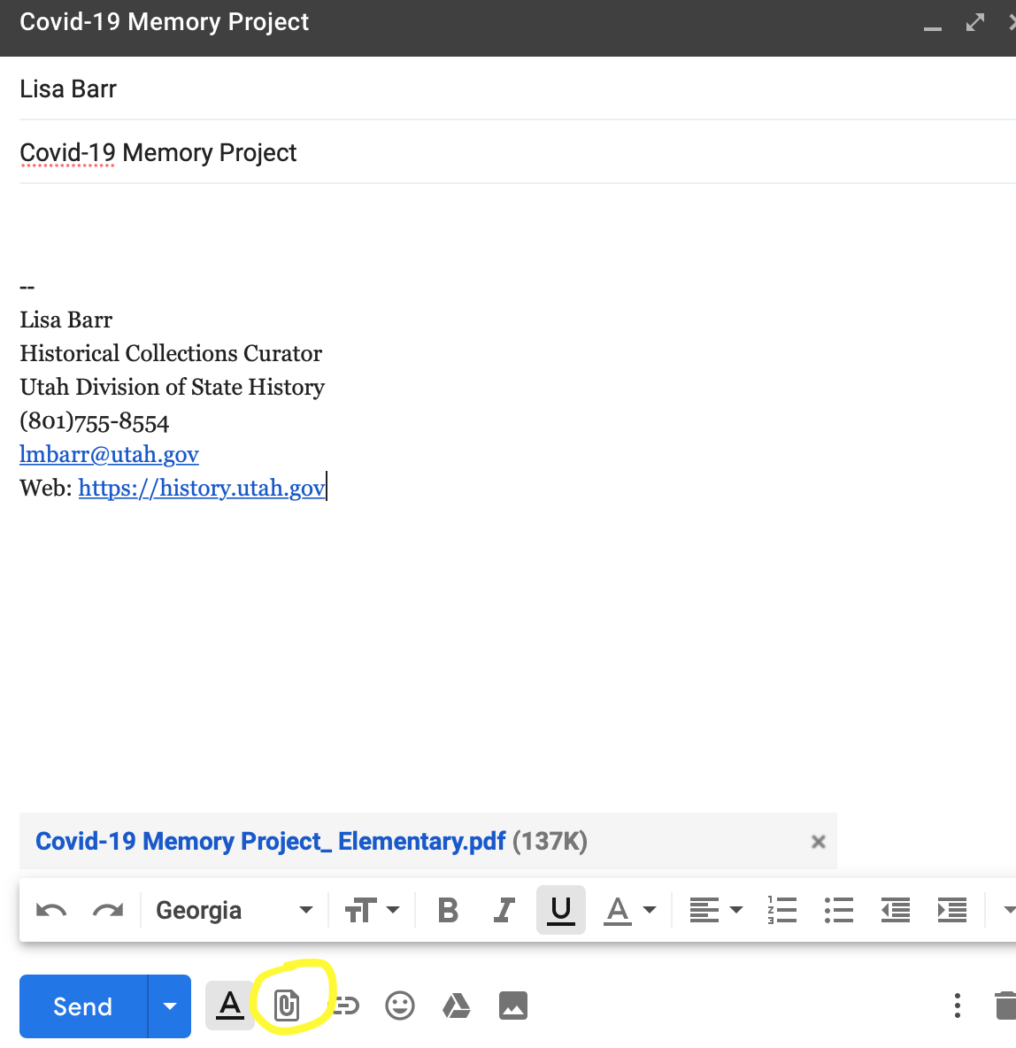

How to Email the PDF in Google Docs:

Go to “File” and then “Email as attachment”
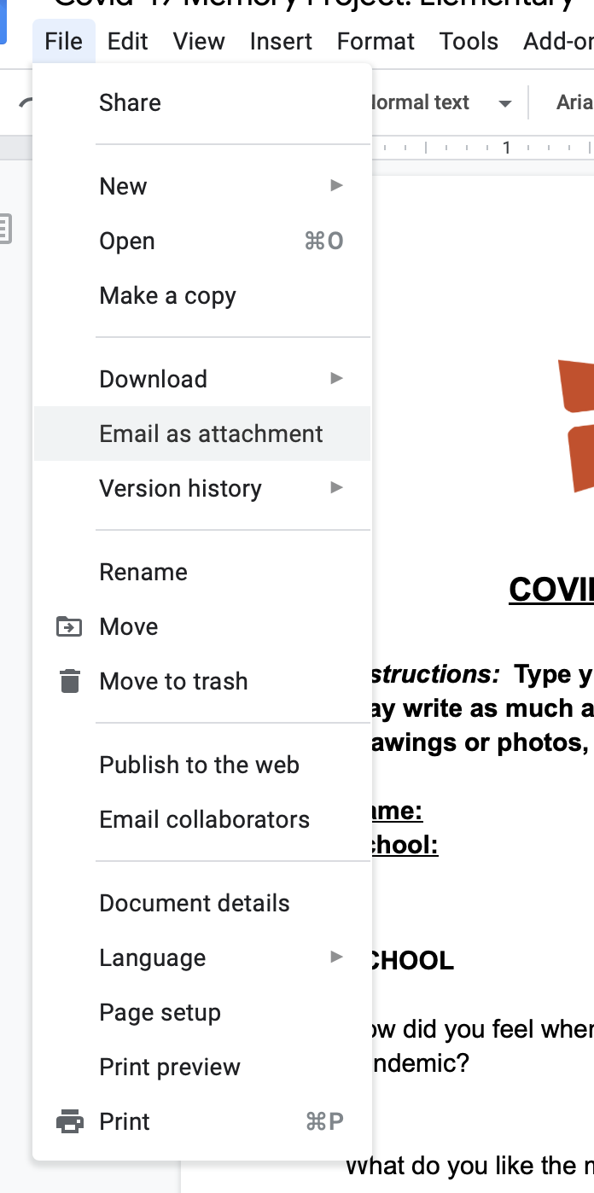
The attachment defaults to a PDF. Send email to lmbarr@utah.gov and include a message if you’d like.
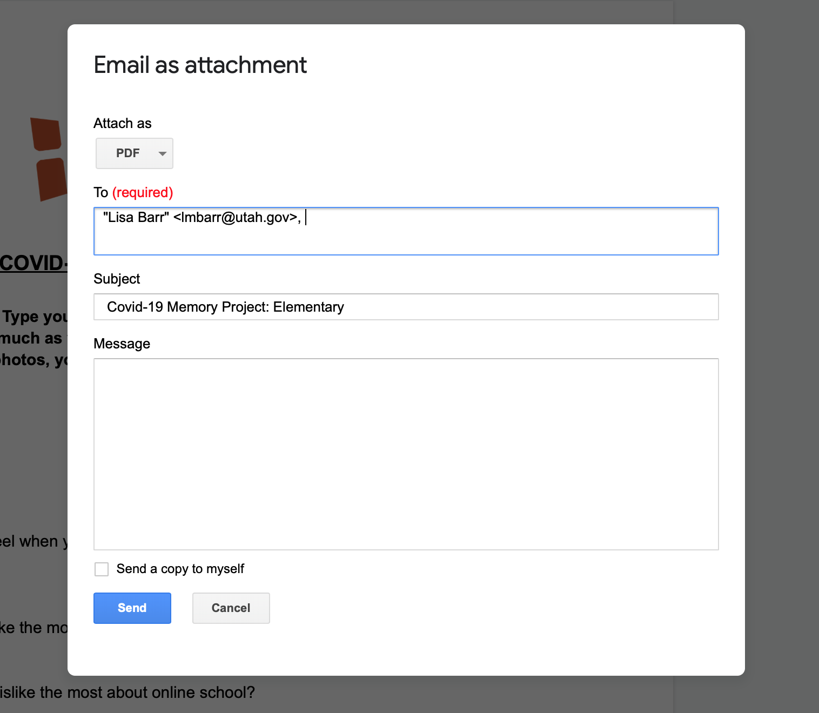

OR:
Go to “File” and click “Download” and choose “PDF Document”.
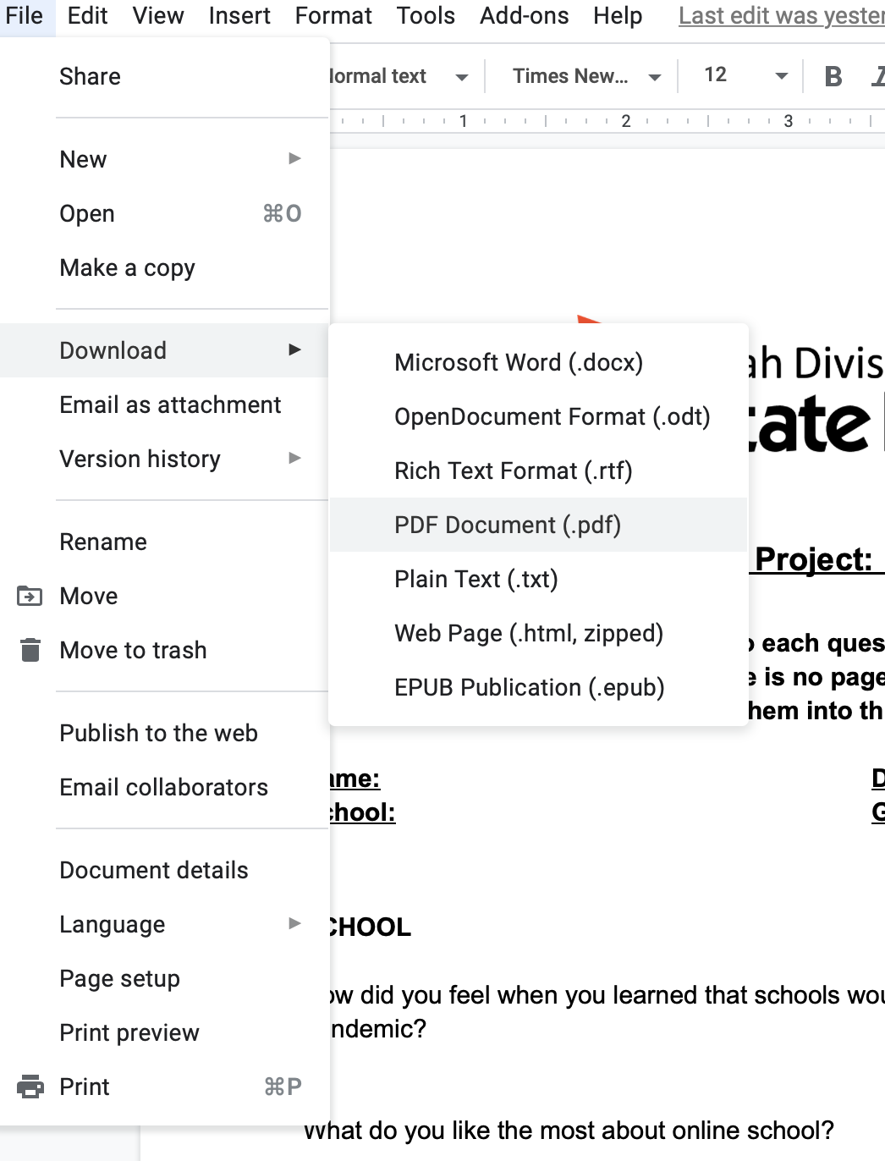

It should download into your “Downloads” on your computer or it will have an option to save into your desired folder.

You can then attach the file when you send your email to lmbarr@utah.gov

